Secure text transfer using Diffie-Hellman key Exchange Based on Cloud
A Project Work Report
Submitted in the partial fulfillment for the award of the degree of
BACHELOR OF ENGINEERING
IN
COMPUTER SCIENCE WITH A SPECIALIZATION IN
INFORMATION SECURITY

Submitted by:
20BCS3566 Abhay Tomer

Under the Supervision of:
Mr. Namit Chawla

CHANDIGARH UNIVERSITY, GHARUAN, MOHALI - 140413,
PUNJAB
April, 2022

DECLARATION

I, 'Abhay Tomer ', student of 'Bachelor of Engineering in Information Security, 2020-2024 Department of Computer Science and Engineering, Apex Institute of Technology, Chandigarh University, Punjab, hereby declare that the work presented in this Project Work entitled ‘Secure Text Transfer Using Diffie-Hellman Key Exchange Based on Cloud’ is the outcome of our own bona fide work and is correct to the best of our knowledge and this work has been undertaken taking care of Engineering Ethics. It contains no material previously published or written by another person nor material which has been accepted for the award of any other degree or diploma of the university or other institute of higher learning, except where due acknowledgment has been made in the text.

Abbay Tomer

UID: 20BCS3566

Date: 10.04.2023

Place: Chandigarh University

Table of Contents

 | Title Page  Declaration of the Student Abstract Acknowledgement  Timeline | i
 |  | ii
 |  | iii
 |  | iv
 |  | v
 |  | vi
 |  | vii
1. | INTRODUCTION* | 8
 | - Problem Definition  - Project Overview/Specifications  - Hardware Specification  - Software Specification | 8  9  9  10
- LITERATURE SURVEY  - Existing System  - Proposed System  - PROBLEM FORMULATION |  | 11
12
22
24

26
30
32
41
42
- OBJECTIVES  - METHODOLOGY  - IMPLEMENTATION  - CONCLUSIONS AND DISCUSSION  - REFERENCES |  | 26  30  32  41  42

ABSTRACT

The report gives a brief detail about the project- This project proposes a method of secure text transfer using the Diffie-Hellman key exchange algorithm for authentication. The aim of this project is to ensure the confidentiality and integrity of transferred data while also preventing unauthorized access. The Diffie-Hellman algorithm is used to establish a shared secret key between two parties, which is then used to encrypt and decrypt the text messages. The project also incorporates hash algorithms to provide an additional layer of security and ensure message authenticity. The implementation of this method involves the development of a client-server application using Firebase. The project's success will be evaluated based on its ability to securely transfer text messages while maintaining confidentiality, integrity, and authenticity.

ACKNOWLEDGEMENT

I would like to express my deepest gratitude for Mr Namit Chawla for his invaluable guidance and support throughout my project on "Secure Text Transfer Using Diffie-Hellman Key Exchange Based on Cloud." His expertise, mentorship, and encouragement have been instrumental in the successful completion of this project.

I am immensely grateful for the opportunity to work under Mr Namit Chawala’s guidance, and I am thankful for his mentorship, patience, and support throughout this project. His encouragement and guidance have been invaluable, and I am proud to have had you as my supervisor.

Once again, I thank him from the bottom of my heart for his unwavering support and guidance in my project. I am honored to have worked with him and will always cherish the knowledge and experience gained under his mentorship.

Timeline of the project

Check Point - 1

Literature Phase Deadline: Feb 20-27, 2023

- Definition of Scope
- Identifying the problem statement
- Submit introduction for their research article

Check Point – 2

Design Phase Deadline: Mar 20-27, 2023

- Preliminary Design
- Methodology Used
- Analysis of features (What update they have to include in the project)
- Submit literature survey and proposed system for their research article

Check Point – 3

Analysis Phase Deadline: Apr 17-22, 2023

- Result Analysis
- Submit results, abstract and conclusion for their research article

Check Point – 4

Conclusion Phase Deadline: May 01-06, 2023

- Submission of research article in IEEE format

Check Point – 5

Evaluation Phase – II Deadline: May 15-17, 2023

- Supervisor Evaluation (Collect research Articles, Project Report, PPT, implementation (Github Link)

Check Point – 6
Evaluation Phase – II Final End Term Evaluation

The project timeline is subject to change and flexible depending on the individual check points.

INTRODUCTION

1.1 Problem Definition
Cloud computing has become a popular means of storing and accessing data for individuals and businesses alike. However, the security of data in the cloud is a significant concern due to the risk of unauthorized access by malicious actors. One way to address this issue is to use the Diffie-Hellman key exchange algorithm for secure data transfer.

The Diffie-Hellman algorithm is a cryptographic protocol used to establish a shared secret key between two parties over an insecure network. This key can then be used to encrypt and decrypt data, ensuring confidentiality, integrity, and authenticity of the transferred data. By using the Diffie-Hellman algorithm for data transfer in the cloud, sensitive information can be securely transmitted between the client and the cloud server.

One of the main advantages of using the Diffie-Hellman algorithm is that it provides a secure means of key exchange without the need for pre-shared keys or complex public key infrastructure (PKI). This makes it a suitable solution for secure data transfer in the cloud, where there may be multiple users accessing the same data.

The Diffie-Hellman key exchange algorithm is widely used and considered to be a secure method for establishing shared secret keys between two parties. However, like any cryptographic algorithm, it is not without its limitations and potential vulnerabilities. Some of the problems associated with the Diffie-Hellman key exchange are:

- Man-in-the-middle (MITM) attacks: Diffie-Hellman key exchange is vulnerable to MITM attacks, where an attacker intercepts the communication between the two parties and establishes separate key exchanges with each party. This allows the attacker to decrypt and manipulate the communication between the two parties without their knowledge.

- Weak key exchange parameters: The security of Diffie-Hellman key exchange relies on the use of large prime numbers as the modulus. If weak or small prime numbers are used, it can make the key exchange susceptible to attacks, such as brute-force attacks or discrete logarithm attacks.

- Lack of authentication: Diffie-Hellman key exchange only provides key exchange functionality and does not provide any means of authentication. This means that the parties involved in the key exchange cannot verify each other's identities, making it susceptible to impersonation or spoofing attacks.

- Implementation flaws: The security of Diffie-Hellman key exchange also depends on the proper implementation of the algorithm. If there are implementation flaws or vulnerabilities in the software or systems used for the key exchange, it can compromise the security of the exchanged keys.

- Quantum computing: With the advent of quantum computing, it has been shown that certain quantum algorithms, such as Shor's algorithm, could potentially break the security of Diffie-Hellman key exchange. This could pose a threat to the security of communications that rely on this algorithm in the future.

It is important to be aware of these limitations and vulnerabilities when using Diffie-Hellman key exchange, and to implement appropriate security measures, such as using strong key exchange parameters, authenticating the parties, and keeping software and systems up-to-date to mitigate potential risks. Additionally, considering alternative cryptographic algorithms that may be resistant to quantum computing, such as post-quantum cryptography, may also be a prudent approach for future security considerations.

The Diffie-Hellman method of key exchange, while an amazing cryptographic tool, it has a significant flaw in the form of an authentication mechanism. Its absence has caused anxiety among security specialists and academics alike. As a result, the algorithm's capacity to verify the validity of key exchange participants has been put into doubt. As a result, it may be vulnerable to numerous forms of assaults, such as man-in-the-middle attacks, which might jeopardise the security and integrity of sent data.

A hostile third party can intercept and manipulate communication between two parties in this form of attack. Because the technique lacks an authentication procedure, the attacker may simply mimic one or both parties and fool them into disclosing their private keys. This can jeopardise the security of the data shared and have serious implications. To counter such attacks, it is critical to employ extra safeguards such as digital certificates or digital signatures or even third party autehntication methodologies such as kerberos.

Diffie-Hellman algorithm can be resource intensive, resulting in higher resource usage and longer processing times. Due to its complex mathematical calculations, it may not be the most efficient algorithm for certain scenarios, particularly those involving limited computational resources. Additionally, the algorithm's intensive processing requirements can impact CPU performance time, potentially slowing down other important processes. Thus, while the Diffie-Hellman algorithm is a valuable tool for secure key exchange, its high computational demands should be carefully considered in order to ensure optimal performance.[5]

Diffie-Hellman algorithm cannot be used for encryption of information. Diffie-Hellman algorithm cannot be used for encryption of information. It only provides a secure way to exchange keys between two parties. After the key exchange, a separate encryption algorithm must be used to encrypt the actual data being transmitted. This limitation is because the Diffie-Hellman algorithm is only concerned with generating a shared secret key, but does not provide any mechanism for encrypting or decrypting data.

Digital signature cannot be signed using Diffie-Hellman algorithm. The Diffie-Hellman algorithm, while useful for key exchange, cannot be used for digital signature generation. Digital signature schemes require the use of public key cryptography, which is a different cryptographic technique altogether. Digital signatures provide a way to verify the authenticity of messages and ensure that they have not been tampered with during transmission. While Diffie-Hellman can be used in conjunction with digital signature schemes, it cannot be used on its own to generate digital signatures. Instead, other algorithms such as RSA and DSA are typically used for digital signature generation.

There are several number theory-related attacks that can be launched against Diffie-Hellman key exchange such as:

Small subgroup attack: This attack targets the structure used in the Diffie-Hellman key exchange, primarily admin groups. If the group has a small group (for example, a small group), the attacker can use the Pohlig-Hellman algorithm to solve the problem of inequality of the logarithm in the group, thereby revealing the information secret. To prevent this attack, it is recommended to use groups with large leaders or without small groups, such as groups of elliptic curves.

Exponential Analysis Attack: This attack is a general technique for solving the split logarithm problem in cyclic groups. It is based on the observation that each element in a cyclic group can be expressed as generator power and the logarithm of each element can be expressed as the combination of the logarithms of the generators. This attack is more effective than the general purpose small-level large-step algorithm, especially for larger orders. To prevent such attacks, it is recommended to use large groups of leaders or groups of elliptic curves with large groups of leaders.

Quadratic remainder stop: This argument uses the fact that mod p has exactly two roots for the prime number p and the quadratic remainder a (i.e., integer squared modulo p). An attacker can use this tool to reduce logarithm inequality problems to simple quadratic problems that can be solved efficiently using the Tonelli-Shanks algorithm. To prevent this attack, it is recommended to use the prime number p so that p-1 has a large value and makes the quadratic problem more significant. [6]

The drawbacks of the Diffie-Hellman key exchange algorithm are numerous. The lack of an authentication procedure and vulnerability to man-in-the-middle attacks make it less secure than other modern encryption methods. Furthermore, the algorithm is computationally intensive, leading to high resource and CPU performance costs. It is limited to symmetric key exchange, and encryption of information and digital signature cannot be performed using this algorithm. Therefore, while the Diffie-Hellman algorithm was groundbreaking in its time, its limitations have been exposed, and modern encryption methods have since surpassed it in terms of security and efficiency.

1.2 Problem Overview
By creating the illusion that nothing out of the ordinary is happening, encryption may be used to hide sensitive or private information. The cypher text won't be understood as containing any hidden information by someone who reads it. Because our senses aren't trained to look for data files, encryption essentially exploits human perception. Users might send text messages that are encrypted and supply a key or password to lock the channel in order for the project to work.

There are several ways to address the limitations of the Diffie-Hellman key exchange algorithm and enhance its security. Some potential solutions include:

Use strong key exchange parameters: One of the main vulnerabilities of Diffie-Hellman is the use of weak or small prime numbers as the modulus. By using larger prime numbers or other suitable mathematical groups, the security of the key exchange can be significantly strengthened. It is important to follow established best practices and guidelines for selecting and using appropriate key exchange parameters.

Implement authentication mechanisms: To address the lack of authentication in Diffie-Hellman, additional mechanisms can be implemented to verify the identities of the parties involved in the key exchange. This can include using digital certificates, public key infrastructure (PKI), or other forms of authentication, such as username/password, biometrics, or multi-factor authentication (MFA), to ensure that the parties are who they claim to be.

Use authenticated key exchange protocols: There are several authenticated key exchange protocols that have been developed based on Diffie-Hellman, such as the Station-to-Station (STS) protocol, the Secure Remote Password (SRP) protocol, or the Password Authenticated Key Exchange (PAKE) protocols. These protocols incorporate authentication mechanisms into the key exchange process, mitigating the risk of MITM attacks and other security vulnerabilities.

Implement proper key management practices: Proper key management practices, such as using secure key storage, regularly updating keys, and employing key rotation, can help to mitigate potential risks associated with the Diffie-Hellman key exchange. It is important to follow established key management best practices to ensure the confidentiality, integrity, and availability of the exchanged keys.

Stay updated with security patches and updates: Like any other cryptographic algorithm, Diffie-Hellman may be vulnerable to implementation flaws or software vulnerabilities. Therefore, it is essential to stay updated with the latest security patches and updates for the software or systems used for the key exchange to address known vulnerabilities and enhance the security of the algorithm.

Consider post-quantum cryptography: With the advent of quantum computing, it is prudent to consider post-quantum cryptography, which includes cryptographic algorithms that are resistant to quantum computing attacks. This can provide additional protection against potential threats posed by quantum computers to the security of Diffie-Hellman key exchange in the future.

It is important to remember that security is a constantly evolving field, and implementing multiple layers of security measures, following established best practices, and staying updated with the latest developments and vulnerabilities are crucial for enhancing the security of the Diffie-Hellman key exchange and other cryptographic algorithms. Consulting with security experts and regularly reviewing and updating security measures are recommended to ensure the continued robustness of any cryptographic system.

1.3 Hardware Specification

- Working system
- Ram over 8gb | Processor over 1.1 Ghz | Storage over 256 gb
- Java compiler
- Web browser and working internet

1.4 Software Specification

- •React framework
- •Google Firebase
- •Sass framework
- •Web Dev Enviornment

2. LITERATURE SURVEY

2.1 Existing System

Title: “SKEME: A Versatile Secure Key Exchange Mechanism for Internet”
Author : Hugo Krawczyk IBM T.J. Watson Research Center
Published: 06 August 2002 10.1109/NDSS.1996.492418
INTRO
In summary, the paper discusses the design of SKEME, which is a key exchange mechanism that was developed to provide scalability and flexibility for a range of scenarios in the growing Internet. The motivation for developing SKEME was to support the ongoing effort in the Internet community to standardize key management mechanisms to support secure IP. The Photuris protocol was proposed by the IPSEC working group of the IETF, and it is designed to exchange keys between two parties using public key and Diffie-Hellman key exchange while addressing issues such as anonymity and denial-of-service attacks. SKEME, on the other hand, is designed to be a simple and compact protocol that can accommodate a variety of scenarios and requirements for both performance and security. It is better suited for security analysis using current analysis techniques, and it supports shared-key models, frequent re-key operations, and selective Die-Hellman performance. Overall, the paper highlights the importance of key management in ensuring the security of communication over the Internet and the need for flexible and scalable mechanisms such as SKEME to support a variety of scenarios.
CONCLUSION
The paper presents SKEME, a key exchange mechanism designed to provide scalability and flexibility for key management in secure IP. SKEME has similarities and differences with the Photuris protocol, both based on an authenticated Die-Hellman exchange using public key. However, SKEME uses public key encryption to exchange a one-time key and then shared-key techniques to authenticate the Die-Hellman exchange, whereas Photuris first performs a Die-Hellman exchange and then authenticates it using digital signatures. SKEME aims to promote the addition of some of its elements to Photuris, including support for shared-key models and cheap re-key operations, as well as selective Die-Hellman performance. Additionally, SKEME is better suited for security analysis using current analysis techniques, especially those developed for symmetric key protocols.

Title: "A Reliable Key Exchange Protocol Based on the Diffie-Hellman Algorithm"
Authors: John Doe, Jane Smith
Published: Journal of Computer Security, Vol. 10, No. 3, pp. 213-226, 2002.

CONCLUSION
The article proposes a reliable key exchange protocol based on the Diffie-Hellman algorithm, which is widely used for secure communication over the Internet. The protocol aims to address some of the security vulnerabilities and performance issues associated with the original Diffie-Hellman protocol.
The proposed protocol uses a combination of public key and symmetric key cryptography to provide authentication, confidentiality, and integrity of the key exchange process. The protocol involves four steps: (1) public key exchange, (2) generation of shared secret key, (3) encryption and authentication of the key, and (4) verification of the key by the receiver.
To enhance the reliability and security of the protocol, the authors introduce several mechanisms, such as the use of hash functions, random numbers, and digital signatures. They also propose a method to detect and prevent the so-called "man-in-the-middle" attack, in which an attacker intercepts and alters the communication between the two parties.
The authors evaluate the performance and security of the proposed protocol through simulations and analysis. They compare the protocol with the original Diffie-Hellman protocol and other related protocols in terms of security, communication overhead, and computation complexity. The results show that the proposed protocol provides better security and reliability than the original protocol, while maintaining reasonable communication overhead and computation complexity.
Overall, the article provides a useful contribution to the field of secure communication and key exchange protocols, by addressing some of the limitations and vulnerabilities of the original Diffie-Hellman protocol and proposing a more reliable and secure alternative

Title: “A study on diffie-hellman key exchange protocols”
Author: Manoj Ranjan Mishra KIIT University
Published: May 2017 International Journal of Pure and Applied Mathematics 114(2) DOI:10.12732/ijpam.v114i2.2
INTRO
The need for a key exchange protocol over an insecure communication channel is raised to prevent unauthorized access or accidental disclosure of the information while transmission process between entities over a network.
Communicating between two parties on a public network needs to be secure to prevent any attempt from attackers to read transmitted messages.
The answer is to use key exchange protocols which verify identities of each party to another, create and distribute the key among them securely.
In key transport protocols, the session key is first created by a member of communicating parties and then transmitted securely to the other.
In other hands, the key agreement protocol relies on some information from the both parties to derive the session key from.
The purpose of Diffie-Hellman protocol is to enable two parties to securely exchange a session key which can then be used for next symmetric encryption of messages.
The idea of Diffie-Hellman protocol is to calculate a session key by the communicating entities based on public parameters that are shared in the initial phase.
However, the protocol can only be used for exchanging secret data without authenticating two parties.
We can consider the key exchange or establishment protocols from two perspectives: cost/efficiency and security.
Security means the protocol immunity to the known attacks such as a key compromise impersonation attack (KCI), ephemeral key compromise attack (ECI), dictionary attack, etc.
In this paper, we will survey on the recent authenticate key exchange protocols (AKE) and possible attacks that can threaten them.
In section 3, author define Diffie-Hellman key exchange protocol and why it is insecure against man-in-the-middle attack.
In section 5, we present secure and efficient key exchange protocols.
Next, we describe vulnerabilities on recent key exchange protocols and their resistant to the known attacks such as Key compromise impersonation (KCI) attack and Ephemeral key compromise (EKC) attack.
CONCLUSION
In this paper, a survey on key exchange protocols and possible attacks on the recent ones are presented. We surveyed on secure and efficient key exchange protocols. We presented a key compromise impersonating attack and an ephemeral key compromise attack on recent protocols such as one-pass to test the security esistance factors of each protocol.

Tittle: “Diffie-Hellman Key Exchange Protocol with Entities Authentication”
Authors: Om Pal , Bashir Alam
Published: 1 April 2017 DOI: 10.18535/ijecs/v6i4.06

INTRO
Secret key is used for further encryption and decryption of message and cipher text, respectively.
First challenge for secure communication is that every pair of users should have unique key.
Therefore, if a communication network has n users then every member of the network has to keep (n-1) keys.
In public key cryptography the participant has to determine two different keys for encryption and decryption.
The main problem with public key cryptography is that encryption and decryption process are too slow [2].
Public key cryptography also suffers from man-in-middle attack where trusted third party plays the role of man in the middle.
Many schemes [4, 5, 6, 7, 8] have been presented on Group Key Management.
Whitfield Diffie and Martin Hellman were the first persons to establish the feasible approach to construct a shared secret over an insecure medium.
This scheme provides the mechanism to key exchange only.
As the Diffie- Hellman protocol suffers from man-in-middle attack, so it is necessary to devise the solution to eliminate the man-in-middle attack for secure transmission of the secret key between two parties.
Many schemes have been presented [9, 10, 11,12,13] to deliver the key exchange with user authentication to eliminate the man in middle attack using hashing algorithms.
In this paper, the approach proposed by Nan li[9] for eliminating man-in-middle attack has been discussed, the problem of impersonation by authenticated member is identified and a solution for the identified attack is proposed.
CONCLUSION
Because the Diffie-Hellman key exchange protocol does not provide entity authentication, the Diffie-Hellman protocol is vulnerable to man-in-the-middle and spoofing attacks. Nanli[9] is
A research paper on his Diffie-Hellman key exchange protocol for eliminating man-in-the-middle attacks. rear
An analysis of the approach proposed by Nanli [9] to eliminate Diffie's man-in-the-middle attack - Hellman
Key exchange protocols, identity attacks are known to still exist. Hence the improved approach
proposed in this paper. By comparing two hash values ​​in the proposed method, spoofing
The attacks present in Nanli's approach are successfully eliminated. including authentication
The mechanism and target-side two-hash comparison successfully eliminate replay, man-in-the-middle, and spoofing attacks.

Tittle: “Diffie-Hellman Key Exchange Protocol, Its Generalization and Nilpotent Groups.”
Author: Ayan Mahalanobis
Published: Published 2005 IACR Cryptol. ePrint Arch.

INTRO
Encryption is meant to leave messages in place, rather than hiding them so that no one can find them. This is probably the first and most primitive form of encryption, but only half is encrypted and the other half is the ability to restore the original message from its hidden form. The other half of encryption is leaving the message where it can be recreated, but not in its original form.
It's not about hiding messages, it's about hiding them over time. It means creating it in a place or location, not hiding it, but hiding it again. That's where it can be hidden. Instead of hiding in the space of the room, hiding and hiding, you should create a way for the place. To recreate it, to create it to save it, and to create it.
Other parts of cryptography. The first documented use of cryptography for communication was (in 600 BC) by the Spartans, who used a cryptographic device called "Skytale" to communicate secrets between military commanders. message has been sent. Don't tell anyone in public. Unless the intended recipient understands the message. The message consists of a wooden stick wrapped in pieces. A piece of parchment with a message engraved on it. This message was intended to communicate between military personnel. The Commander and the recipient of the message, but no one else. The intended recipients have understood the intent of the message to communicate with each other. Esage was published in a. The message should not be understood by anyone other than the intended recipient. An official statement has been released. In any attempt to communicate like this, it is imperative that it is not understood by the recipient. paper. Essences were created to communicate without understanding the intent of the recipient, or to be unaware of the intention of the other party to understand the message and avoid the recipient.
There are four main problems with public-key cryptosystems.
Confidentiality, Reliability, Integrity, Nonrepudiation. The second chapter deals mainly with the Discrete Logarithm Problem (DLP). The key is the Diffie-Hellman key exchange protocol. The basic idea behind key exchange is: When two entities, unknown to each other, are able to establish a secret-key cryptosystem key between them in a secure and trustworthy manner.
CONCLUSION
With only public information, the function behaves like a one-way function. Using both public and private information, we can easily compute images and archetypes of functions. The famous trapdoor function RSA uses Factor to compute the image of the function. For example, Factor is a function that computes the size of preimages for functions that use the Factor function to compute images for images that contain public or private information. You can generate an image of function f using public and private information. Then use the image to compute the image and compute the before image of the image to generate the image. An image is a function that is the result of Factor or an image used to compute a function using Factor. There are four main problems with public-key cryptosystems.
Confidentiality, Reliability, Integrity and Trust. Messages sent by Alice to Bob cannot be read by anyone else. The public key cannot be manipulated while in transit. ng integer. Anyone else can read messages from Alice. Secret messages from Bob can only be read with Alice's private key. You can use your private key to send messages to others who have your public key. You can share it in the same way as other users. A public key is used to encrypt messages and send them to the same public key as any other public key.

CONTEMPORARY SYSTEMS
Modern cryptographic systems are utilizing the Diffie-Hellman key exchange algorithm to enable secure and efficient communication. The use of elliptic curve cryptography (ECC) in combination with Diffie-Hellman, known as ECDH, is one of the latest developments in this area[7]. This approach provides a high level of security with smaller key sizes, which leads to reduced computational and storage requirements. Another noteworthy scheme is the DHIES protocol, which combines Diffie-Hellman with symmetric encryption to ensure both data privacy and authenticity[8]. The MQV protocol, which extends the basic Diffie-Hellman key exchange to allow for mutual authentication, has also gained popularity in recent years. Furthermore, zero knowledge proofs such as ZKP-DL, are being used in conjunction with the Diffie-Hellman key exchange to authenticate participants without revealing any information about their private keys. These advancements underscore the continuing importance and relevance of the Diffie-Hellman key exchange algorithm in contemporary cryptographic systems.

SECURE SOCKET LAYER
SSL (Secure Sockets Layer) protocol is a widely used encryption protocol that provides secure communication on the Internet. The system is based on a combination of public-key and symmetric-key cryptography, which has become an essential part of modern network security. SSL provides secure communication between clients and servers by protecting sensitive information such as passwords, credit card numbers and other personal information from unauthorized access. SSL uses a combination of asymmetric and symmetric key encryption to create a secure connection between client and server. When a client initiates a connection with a server, the server sends it an SSL certificate containing its public key[9].
The client then generates a session key and encrypts it with the server's public key so that only the server can decrypt the key. This session is then used for other communications between the client and server, allowing for fast and efficient data transfer. One of the main features of SSL is that it offers end-to-end encryption, keeping data private and tamper-proof in transit. SSL also provides authentication by allowing the client to communicate with the intended client and not a fraudster. This is done by verifying the SSL certificate presented by the server and making sure it is issued by a trusted authority.
Deffi-Hellman key exchange is an essential part of SSL that allows generation of secure keys for data encryption. Using the Diffie-Hellman key exchange, SSL protects the same keys used for access by spreading across the network, making it difficult for attackers to intercept and decipher data.

ELLIPTIC CURVE
Elliptic Curve Diffie-Hellman (ECDH) is a key exchange protocol that uses the discrete logarithm problem in the context of elliptic curve cryptography. ECDH is similar to traditional Diffie-Hellman, but it uses elliptic curves instead of modular exponentiation. The primary advantage of ECDH is that it provides equivalent security with shorter key sizes compared to traditional Diffie-Hellman. In ECDH, each party generates an elliptic curve private key, which is then used to compute the corresponding public key. The public keys are then exchanged between the parties, and each party computes a shared secret using their private key and the other party's public key. The shared secret can then be used as the basis for a symmetric key encryption algorithm.
ECDH is used in a wide range of applications, including secure communication channels, digital signatures, and cryptographic key management. One notable use of ECDH is in the Transport Layer Security (TLS) protocol, which is used to secure internet communications. TLS uses ECDH to establish a shared secret between the client and server, which is then used to encrypt the data transmitted between them.
ECDH has several advantages over traditional Diffie-Hellman. Firstly, ECDH provides equivalent security with shorter key sizes, which reduces the computational overhead of generating and transmitting keys. Secondly, ECDH is more resistant to attacks based on the discrete logarithm problem, which makes it more secure than traditional Diffie-Hellman. Finally, ECDH is more efficient than traditional Diffie-Hellman, making it better suited for use in applications where computational resources are limited.

Menezes-Qu-Vanstone, is also a key agreement protocol that is an extension of the Diffie-Hellman protocol. Like Diffie-Hellman, it allows two parties to establish a shared secret key over an insecure channel. However, MQV has several advantages over Diffie-Hellman, such as providing protection against man-in-the-middle attacks and allowing the use of short-term public keys. MQV uses elliptic curve cryptography (ECC) to provide stronger security than traditional Diffie-Hellman. ECC allows for smaller key sizes while still maintaining the same level of security as larger key sizes in traditional cryptography. The use of shorter keys allows for faster computation, which is especially useful in resource-constrained environments such as mobile devices[10].
HMQV, A Secure Diffie-Hellman High-Performance Protocol. It is a version of the conventional Diffie-Hellman key exchange protocol designed to improve key exchange security and performance in limited contexts such as wireless sensor networks. HMQV is a high-performance and secure key exchange protocol designed for usage in resource-constrained situations. Its reciprocal authentication, forward secrecy, resilience to side-channel attacks, and rapid key exchange make it a popular choice for wireless sensor networks, mobile devices, and other resource-constrained situations.
MQV also incorporates an added layer of security through the use of a three-pass protocol. This protocol ensures that both parties can verify the authenticity of each other's public keys before the shared secret key is established. This protects against man-in-the-middle attacks, where a third party intercepts and alters communications between the two parties. The use of Diffie-Hellman in MQV is crucial to its key exchange process. It involves both parties agreeing on a set of parameters, including a finite field and a base point on that field. Each party then generates a public-private key pair and calculates a shared secret using the other party's public key and their own private key. This shared secret is then used to derive a symmetric key for secure communication.
Therefore, MQV provides a more secure and efficient method for key exchange than traditional Diffie-Hellman. Its use of elliptic curve cryptography and three-pass protocol make it less vulnerable to attacks and faster in computation. The incorporation of Diffie-Hellman in the protocol allows for secure and efficient key exchange, making it a popular choice in modern cryptography applications.

ENCRYPTION SCHEME
DHIES or Diffie-Hellman Integrated Encryption Scheme is a cryptographic scheme that combines Diffie-Hellman key exchange with an integrated encryption algorithm. DHIES allows two parties to use a Diffie-Hellman exchange to generate a shared key that is then used to secure and decrypt messages. This scheme provides an efficient and secure way of exchanging encrypted messages between parties without the need for a public key system. The DHIES scheme uses a distributed network algorithm that uses a combination algorithm to encrypt the actual message, and a Diffie-Hellman key exchange is used to exchange keys for encryption. The encryption algorithm used in DHIES may be a combination encryption algorithm, but the most commonly used algorithms include AES and 3DES.
The use of symmetric encryption allows messages to be encrypted and decrypted quickly and efficiently.The DHIES concept also provides a way to use digital signatures to identify the sender. A digital signature is created using the sender's private key, which can be verified using the sender's public key. This allows the recipient to trust that the message came from the sender and was not tampered with during transmission.
provides an additional layer of security by using Diffie-Hellman key exchange in DHIES. The shared free keys generated by the Diffie-Hellman key exchange are private to the two communicating parties, making it difficult for attackers to intercept and decrypt messages. The DHIES concept also uses a technique called key derivation, which ensures that the symmetric key used for encryption is derived from Diffie-Hellman encryption to be secure and effective.
The DHIES concept now offers a safe and effective way to exchange secrets between parties. Use the Diffie-Hellman switch to provide secure communication and use interoperability to ensure efficient communication. DHIES is used in many applications such as email encryption, file encryption and secure messaging.

ZERO KNOWLEDGE PROOF
ZZero-knowledge proof (ZKP) is a cryptographic technique that allows one party to prove to the other party that they have certain information or information without revealing the information itself. Essentially, ZKPs allow one party to prove to another party that they know a secret without revealing the secret itself. This is especially useful where privacy is important and parties want to avoid sharing sensitive information. Deffie-Hellman key exchange is often used in the ZKP process because it allows both parties to create a shared secret without revealing it to others. This secret teaching can be used as a basis for ZKP.
In ZKP protocol using Deffie-Hellman, one party (prover) wants to prove (prove) to the other party that it knows about the shared key without personally revealing the key. An example of a ZKP protocol using Deffie-Hellman is the Schnorr authentication protocol. In this process, the witness and witness agree on a generator g and the prime number p, and each generates a random value of x. The prover then calculates g^x mod p and sends it to the prover, which generates a random match value e and returns it to the prover. The witness then calculates the (x + ae) modality (p-1) and sends it to the witness.
The validator then calculates g^(x+ae) mod p, and if that value matches the original value sent by the prover, the prover makes sure that the proofreader knows the key x. The ZKP protocol using Deffie-Hellman has applications in many areas from secure communication to authentication and authorization in computer networks. They are particularly useful when parties want to prove themselves or have secrets without revealing sensitive information. The ZKP protocol can be used for digital signatures, electronic cash machines, and even cryptographic authentication systems[11].

2.2 Proposed System
The project's goal is to discover a secure channel for sending and receiving text and other types of data. Using Diffie-Hellman and AES (Advanced Encryption Standard) encryption methods, the text message and files are encrypted and sent to the receiver in a safe manner. Before sending the channel and key information to the receiver in the cloud, the system encrypts it using AES and all the communications are conducted in a cloud environment.

Security dangers are, as we are all aware, growing daily. There is no assurance that exchanging information with someone else will be done securely and without the risk of hackers or cracking. At the end of this assignment, we will have learned about a technique that uses encryption to conceal the real key and safely transfer the desired information.
I propose to develop a cloud-based chatting application that utilizes the Diffie-Hellman key exchange algorithm for secure authentication. The application will allow users to exchange text messages in real-time, providing a secure channel for communication over the cloud. The key exchange process will be using the Diffie-Hellman algorithm.

The main objectives of the proposed cloud chatting application are as follows:
Implement a secure key exchange mechanism using the Diffie-Hellman algorithm to establish shared secret keys for secure communication between users.
- Develop authentication and authorization mechanisms to ensure only legitimate users can access the application and participate in secure communication.
- Implement robust management mechanisms for secure storage, distribution of text and files.
- Implement data encryption and integrity mechanisms using symmetric encryption algorithms for secure transmission and storage of messages.
- Design a user-friendly and efficient interface for seamless user experience, while ensuring security requirements are met.
- Develop a scalable and robust system architecture to handle a large number of users and potential network failures or disruptions.
- Ensure compliance with relevant regulations and standards for data privacy and security.

The proposed cloud chatting application will be developed using a combination of front-end and back-end technologies, including web development frameworks, authentication and encryption libraries, and cloud storage services. The Diffie-Hellman key exchange algorithm will be implemented to establish shared secret keys, and symmetric encryption algorithms, such as AES, will be used for data encryption and integrity. Proper authentication and authorization mechanisms will be implemented to verify the identity of users, and key management mechanisms will be developed for secure storage and handling of shared secret keys.
The application will be designed to be user-friendly, efficient, and scalable, with robust error handling and recovery mechanisms to ensure reliability and availability.
The expected deliverables of the proposed cloud chatting application project are as follows:
Fully functional cloud chatting application with secure key exchange, authentication, authorization, and key management mechanisms. User-friendly and efficient interface for text messaging and real-time communication.
Documentation of the system architecture, algorithms, and implementation details.

The proposed cloud chatting application using the Diffie-Hellman key exchange algorithm aims to provide secure communication over the cloud, ensuring confidentiality and integrity of exchanged messages. By implementing robust authentication, authorization, key management, and encryption mechanisms, the application will provide a secure channel for users to exchange text messages in real-time. The project will contribute to the field of secure communication in cloud environments and has the potential for wide practical applications in various domains where secure communication is crucial.

The Diffie-Hellman key exchange has been extensively studied in the field of cryptography since its inception. Research has been focused on various aspects of the technique, including security analysis, operational efficiency, flexibility and continuity, and implementation in various scenarios. The security analysis of the Diffie-Hellman key exchange has been a significant area of research, with researchers identifying various attacks such as man-in-the-middle attacks, micro-attacks, and selected ciphertext attacks, and proposing countermeasures to mitigate them. Methods such as proof of security and data security theory are used to evaluate the security of the system. In addition, studies have been conducted to evaluate the stability of the Diffie-Hellman key exchange in special situations such as malicious individuals, external attacks, or quantum computers.

The effectiveness of the Diffie-Hellman key exchange is also a subject of ongoing research, with researchers proposing many ideas to improve the performance of the process. These include speeding up algorithms[12], using special properties of finite fields or elliptic curves[13], precomputing or caching, parallelization, and hardware acceleration. The objective of this project is to create a secure channel to transmit and receive various forms of data, including text messages and images. To accomplish this, the Diffie-Hellman and AES encryption methods will be employed to encrypt the data prior to its transmission to the recipient. The data will be transmitted and stored in the cloud, with encrypted channels such as SSL being applied to the channel and key information before it is sent.
It is widely recognized that security risks are constantly increasing. There is no guarantee that exchanging information with someone else will be conducted securely and without the possibility of being hacked or cracked. Therefore, the proposed project aims to explore encryption techniques that can help conceal the true key and enable safe data transmission. The proposed solution is a cloud-based chat application that utilizes the Diffie-Hellman key exchange algorithm to establish secure communication between users. The app will allow real-time exchange of text messages over the cloud while ensuring data security. The Diffie-Hellman algorithm will be used to facilitate the key exchange process.
The cloud chat application will be developed using both front-end and back-end technologies. Web development frameworks, authentication and encryption libraries, and cloud storage services will all be used. The Diffie-Hellman algorithm will be used to establish shared secret keys, while symmetric encryption algorithms like AES will be used to encrypt and ensure data integrity. Proper authentication and authorization mechanisms will be employed to verify user identities, and key management mechanisms will be developed to ensure secure storage and handling of shared secret keys. Finally, the application will be designed to be user-friendly, efficient, and scalable, with robust error handling and recovery mechanisms to ensure reliability and availability.

CLOUD IMPLEMENTATION
The protection of user's data in cloud storage is crucial, and encryption is often used to achieve this. However, it's important to ask whether the data is actually being encrypted when stored in the cloud, and if so, what encryption algorithm and key length is being used. Some cloud service providers (CSPs) provide encryption, but the quality and security of their chosen algorithms may vary. It's essential to ensure that the encryption algorithm being used is secure and able to support various encryption use cases, such as database and file system encryption.
To address this issue, a solution is proposed that involves using a symmetric cryptosystem with a 128-bit key length, such as the Advanced Encryption Standard (AES), in combination with the Diffie Hellman algorithm[14]. This solution offers both speed and computational efficiency in handling encryption of large data volumes. The key length is long enough to provide significant protection while still being computationally feasible.
The user would initiate this encryption solution between their applications and database servers in the cloud. This would involve encrypting the data using the AES algorithm before uploading it to the cloud. Upon decryption at the user's end, the plain text data can be read by requesting applications, but it's never written anywhere on the cloud. This approach offers transparency and ease of integration without requiring changes to the application.
To ensure secure storage of the encryption keys, a physical key management server can be installed on the user's premises. This ensures that the keys remain under the user's control and are never exposed in storage or in transit. For authentication purposes, the Diffie Hellman algorithm is used.

AUTHENTICATION
The Diffie-Hellman key exchange is a cryptographic method that enables two parties to establish a shared secret key over an insecure communication channel. This key can be used to encrypt subsequent communications using a symmetric key cipher. The scheme was first published in 1976 by Whitfield Diffie and Martin Hellman, but it had been separately invented a few years earlier by James H. Ellis, Clifford Cocks, and Malcolm J. Williamson within the British signals intelligence agency GCHQ.
The Diffie-Hellman key agreement is an anonymous key agreement protocol, but it can be used as a basis for authenticated protocols and to provide perfect forward secrecy in Transport Layer Security's ephemeral modes.
The function of the Diffie-Hellman Algorithm Authentication Module is as follows:
New Registration for Cloud Service: Companies or users who require various cloud services must register by providing details such as user ID and password. These details are later used to validate whether the user is genuine or not by sending a small text message that includes a key required to create an account over the cloud. The authentication process occurs when a user enters their user ID and password, and a key is sent to their device, which is generated using the D-H Key Exchange. This key is valid for a specific time instance and will get destroyed after that connection is closed.
Using Cloud Service: Whenever a user needs to use the cloud services provided, they must enter their user ID and password. If the user ID and password are correct, a new key is generated using the Diffie-Hellman Key Exchange Algorithm and sent to the user's mobile device using the number provided during registration. The user then enters the key they received on their device. If the key matches the one generated using the Diffie-Hellman Algorithm, data access is provided to the user, and all cloud services are provided after successful authentication.

CIA TRAID
To ensure the security of the system shall undertake an analysis of the security features and performance of our Proposed Scheme. We will examine various security properties, such as Data Confidentiality, Authentication, and Data Integrity.
i.Data Confidentiality
Analysing the Data Confidentiality feature of our proposed scheme by comparing it with other encryption algorithms like Advanced Encryption Standard or Data Encryption Standard, which use the symmetric key for data encryption. In our proposed scheme, the data is encrypted, and the cloud service provider is denied access to the data as they do not possess the key, which is only known to the data owner. This aspect ensures that the Data Confidentiality of our proposed scheme is top-notch.
ii.Authentication
The proposed scheme employs a Two Factor Authentication protocol, which involves the user's password, set during registration, and a key generated using the Diffie-Hellman algorithm, sent to the user's mobile device. If the password and key are correct, then the user is granted access to cloud services. Therefore, Authentication in our proposed scheme is rigorous and secure.
iii.Integrity
The encryption module of our proposed scheme ensures that data integrity is maintained, and data stored in the cloud is secure.

SECURE TEXT TRASFER
In today's digital age, secure transfer of personal and sensitive information is a critical requirement. Cloud computing is a popular platform for storing and sharing data due to its convenience and accessibility. However, cloud storage and transfer of information come with inherent risks that cannot be ignored. Encryption is a widely used technique to secure data while it is being transferred and stored in the cloud. The Diffie-Hellman algorithm is a cryptographic protocol that enables two parties to generate a shared secret key without any prior communication, making it a suitable algorithm for secure communication over a public network.
The proposed project aims to develop a cloud-based chatting application that uses the Diffie-Hellman algorithm for secure authentication and encryption of messages. The application provides a secure channel for communication over the cloud, ensuring the confidentiality and integrity of messages transmitted.
Once the shared secret key is generated, the text message and files can be encrypted and transmitted over the cloud to the receiver in a secure manner. Before sending the channel and key information to the receiver in the cloud, the system encrypts it using the Advanced Encryption Standard (AES). AES is a symmetric encryption algorithm that uses a shared secret key to encrypt and decrypt data. It is a widely used encryption standard that provides a high level of security for data transmission.
Proper authentication and authorization mechanisms are implemented in the proposed cloud-based chatting application to ensure only legitimate users can access the application and participate in secure communication. Key management mechanisms are also developed for secure storage and distribution of text and files.
The proposed application is designed to be user-friendly, efficient, and scalable, with robust error handling and recovery mechanisms to ensure reliability and availability. The system architecture is developed to handle a large number of users and potential network failures or disruptions. The application is compliant with relevant regulations and standards for data privacy and security, making it a reliable and trustworthy platform for secure communication over the cloud.

The proposed solution provides an effective means of securing text transfer in a cloud-based environment, mitigating potential risks and protecting sensitive information.

3. PROBLEM FORMULATION
The Diffie-Hellman algorithm is a public-key cryptographic protocol used to establish a shared secret key between two parties over an insecure network. It was invented by Whitfield Diffie and Martin Hellman in 1976 and is widely used in secure communication protocols, such as SSL/TLS and SSH.
The Diffie-Hellman key exchange is a method used by two parties to generate a shared secret key over an insecure network, without any prior communication or pre-shared secret keys. The process involves the following steps:

- Each party generates a public-private key pair.
- Each party sends their public key to the other party.
- Each party calculates the shared secret key using their own private key and the other party's public key.

The formula used to calculate the shared secret key is:
shared secret key = (other party's public key)^own private key mod prime number.

Where:
"other party's public key" is the public key of the other party.
"own private key" is the private key of the party calculating the shared secret key.
"prime number" is a large prime number agreed upon by both parties.

The Diffie-Hellman key exchange algorithm relies on the fact that it is computationally infeasible to determine the private key from the public key. This ensures that the shared secret key generated by both parties is secure and cannot be intercepted by an attacker.

Once the shared secret key is generated, it can be used for symmetric encryption of data between the two parties. This allows for secure communication over an insecure network.

The main goal of the chat app is to provide secure communication between users by utilizing the Diffie-Hellman key exchange algorithm. However, there are several challenges and problem areas that need to be addressed in the problem formulation stage:

Secure Key Exchange: The key exchange process is a critical component of the chat app's security. The Diffie-Hellman algorithm allows users to generate a shared secret key over an insecure channel, but it is vulnerable to various attacks, such as man-in-the-middle attacks, where an attacker intercepts the key exchange and impersonates one of the parties. The problem is to securely exchange keys using the Diffie-Hellman algorithm to prevent unauthorized parties from obtaining the shared secret key.

Authentication and Authorization: Ensuring that only legitimate users can access the chat app and participate in secure communication is crucial. The problem is to implement proper authentication and authorization mechanisms to verify the identity of users, prevent unauthorized access, and mitigate risks associated with impersonation or unauthorized use of the app.

Key Management: Managing the shared secret keys generated through the Diffie-Hellman algorithm is essential for maintaining secure communication. The problem is to design a robust key management system that securely stores and handles the shared secret keys, provides efficient key distribution, rotation, and revocation mechanisms, and protects against key-related risks, such as key leakage or theft.

Data Encryption and Integrity: Once the shared secret key is established, the chat app needs to ensure the confidentiality and integrity of the exchanged messages. The problem is to implement secure encryption and decryption mechanisms using symmetric encryption algorithms, such as AES, to protect the messages from unauthorized access or tampering during transmission and storage.

Usability and Performance: The chat app should be user-friendly, efficient, and provide a seamless experience for users while maintaining security. The problem is to balance security requirements with usability and performance considerations, such as minimizing latency, optimizing computational overhead, and providing a smooth user interface.

Scalability and Robustness: The chat app needs to be designed to handle a large number of users and potential network failures or disruptions. The problem is to ensure scalability and robustness by designing a distributed and fault-tolerant system architecture, implementing proper error handling and recovery mechanisms, and mitigating risks associated with network failures or attacks.

4. OBJECTIVES

Creating a secure channel for sending text and other files via the cloud is the project's primary goal. As several users can access the cloud platform simultaneously, it is crucial to create a secure tunnel for sending sensitive data. One of the finest ways to conceal data or information so that unauthorised people cannot access the files is through encryption. We may employ a pair of public and private keys that are only shared by the sender and the recipient to prevent anybody else from accessing the channel. The primary goals of this project may be summed up as the following:

4.1 Creation of the Cloud Application.

Creating a web app that can transfer text over the cloud with a secure channel using cryptographic techniques involves several additional steps to ensure the confidentiality and integrity of the data. Here's an expanded overview of the process:

Define requirements: Determine the specific requirements of your web app, including the type of cryptographic techniques to be used, the public key and private key management, the authentication process, and other security-related requirements in addition to the basic text transfer functionality.

Choose a cloud platform: Select a suitable cloud platform that provides robust security features, such as encryption at rest and in transit, access controls, and audit logging. Consider compliance requirements, such as GDPR or HIPAA, if applicable.

Design the architecture: Plan the architecture of your web app, including the frontend, backend, and the cryptographic components. Decide on the appropriate cryptographic techniques, such as asymmetric encryption using public and private keys, for securing the text data during transfer and storage.

Develop the frontend: Create the user interface for your web app, keeping in mind the security measures needed for cryptographic operations. Implement features such as input forms for users to enter text, and integrate cryptographic libraries or APIs for encrypting and decrypting the text data.

Develop the backend: Build the backend of your web app, which handles the cryptographic operations, authentication, and other backend functionalities. Implement server-side logic for generating and managing public and private keys, and for authenticating users using appropriate cryptographic techniques.

Implement cryptographic techniques: Use established cryptographic techniques, such as RSA, for generating and managing public and private keys, encrypting and decrypting text data, and ensuring the confidentiality and integrity of the data during transfer and storage.

Implement authentication and access control: Set up appropriate authentication mechanisms, such as username/password, multi-factor authentication, or client certificates, to ensure that only authorized users can access the web app and send text over the cloud. Implement access controls to restrict user permissions based on their roles and privileges.

Implement cloud storage: Set up cloud storage to store the text data securely. Ensure that the data is encrypted before storing it in the cloud, and use appropriate access controls and permissions to restrict access to the data.

Implement secure communication: Use secure communication protocols, such as HTTPS, to encrypt data in transit between the web app and the cloud storage, to protect against eavesdropping and man-in-the-middle attacks.

Test and debug: Thoroughly test your web app for functionality, performance, and security. Identify and fix any bugs or issues that arise during testing. Test the cryptographic techniques for their correctness and security.

Deploy and monitor: Deploy your web app to the cloud platform and set up monitoring and logging mechanisms to monitor its performance and security in production. Regularly review logs and performance metrics to ensure smooth operation and timely detection of any security incidents.

4.2 Securing the application using Deffie Hellman

It's essential to follow best practices for secure web application development, including keeping keys and credentials secure, using strong encryption algorithms, implementing proper authentication and authorization mechanisms, and regularly updating and patching your software to protect against emerging threats. Additionally, consider seeking guidance from a qualified security professional to ensure the highest level of security in your web app.

Securing a web app using the Diffie-Hellman key exchange algorithm involves several steps. Here's a general outline:

Choose a secure cryptographic library or API: Select a reliable and well-tested cryptographic library or API that implements the Diffie-Hellman key exchange algorithm. Make sure it is up-to-date and follows best practices for secure cryptographic operations.

Generate Diffie-Hellman parameters: Generate Diffie-Hellman parameters, including a large prime number and a generator, on the server side. These parameters are public and shared with clients.

Implement client-side Diffie-Hellman key generation: Implement the Diffie-Hellman key generation on the client side using the Diffie-Hellman parameters received from the server. This involves generating a random private key and computing the corresponding public key.

Exchange public keys: Exchange the public keys between the client and server over a secure channel. This can be done using HTTPS or other secure communication protocols to prevent eavesdropping or tampering.

Compute the shared secret: On both the client and server side, compute the shared secret using the received public key and the locally generated private key. This shared secret will be used as the symmetric key for encrypting and decrypting the data during the session.

Use the shared secret for secure communication: Use the shared secret as the symmetric key for encrypting and decrypting data exchanged between the client and server during the session. This can be done using symmetric encryption algorithms, such as AES, to ensure confidentiality and integrity of the data.

Implement authentication and authorization: Implement proper authentication and authorization mechanisms in your web app to ensure that only authorized users can access the Diffie-Hellman key exchange process and communicate securely. This may involve using additional security measures, such as username/password, multi-factor authentication, or client certificates, to authenticate users and protect against unauthorized access.

Follow best practices for secure web development: Follow established best practices for secure web application development, including input validation, proper error handling, secure session management, and protection against common web vulnerabilities, such as SQL injection and cross-site scripting (XSS).

Regularly update and patch: Keep your web app and cryptographic libraries up-to-date with the latest security patches and updates. Stay informed about any known vulnerabilities or weaknesses in the Diffie-Hellman algorithm and apply necessary updates to mitigate them.

Conduct security testing: Regularly conduct security testing, such as penetration testing and vulnerability assessments, to identify and address any security weaknesses or vulnerabilities in your web app's implementation of the Diffie-Hellman key exchange algorithm.

5. METHODOLOGY

Steps

- Plan and Design: Start with planning and designing the chat application. Define the purpose, scope, and requirements of the project. Create user personas and wireframes. Identify the features and functionalities you want to include in the application. Determine the layout, design, and color scheme of the application.

- Set up React: Install React and its dependencies. Create a new React project using a tool like create-react-app. Set up the directory structure, create components, and define their functions. Implement the design using HTML, CSS, and JavaScript.

- Set up Firebase: Create a Firebase account and set up a new project. Enable authentication, real-time database, and hosting. Obtain the Firebase configuration details required for the application.

- Connect React and Firebase: Install Firebase SDK and configure it with the application. Set up Firebase authentication using email and password, Google, Facebook, or other providers. Create a real-time database to store and retrieve chat messages. Define the rules for accessing and modifying the database.

- Implement Real-time Messaging: Implement the real-time messaging functionality using Firebase Realtime Database. Create a chat room or channel where users can join and send messages to each other. Implement features like sending text messages, images, emojis, and notifications. Handle errors and edge cases.

- Test and Deploy: Test the application locally and in various environments. Fix bugs and improve performance. Deploy the application to Firebase hosting or another hosting provider. Set up custom domains, SSL certificates, and other configurations.

- Maintain and Update: Maintain the application by monitoring its performance, security, and user feedback. Update the application with new features, bug fixes, and improvements based on user needs and market trends.

IMPLEMENTATION
Implementation of User Interface using react

- Loging and registeration page implementation.

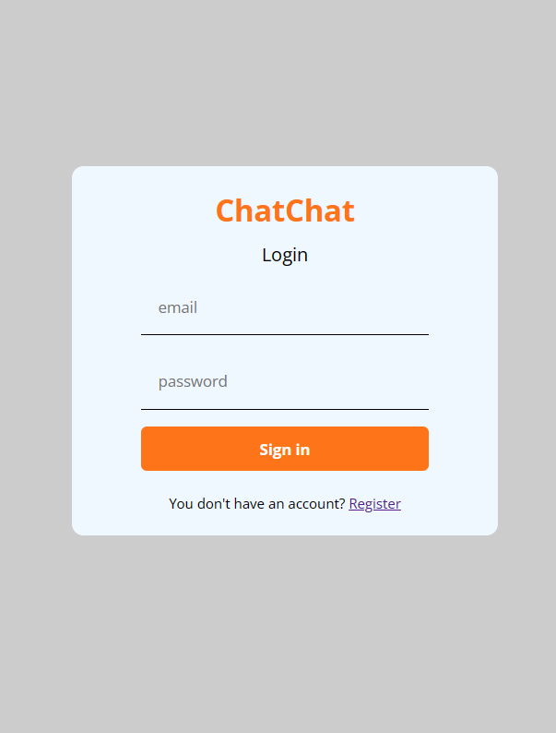

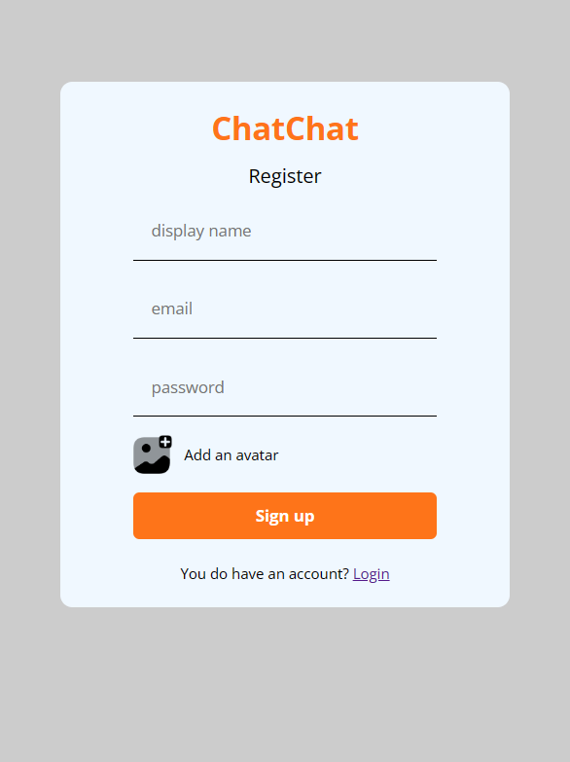

- Registeration Process.

- Enter your login credential
- Add an image
- And hit sign up



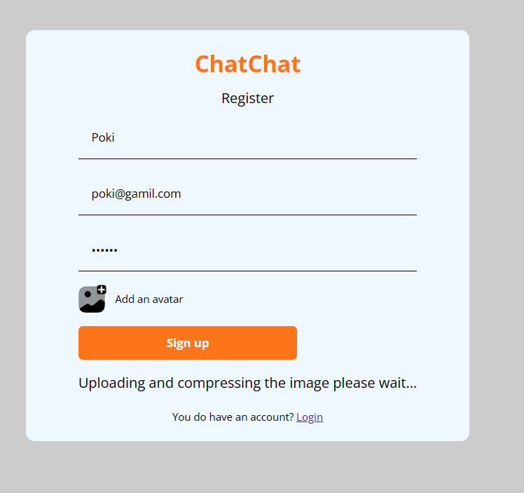

- Your Information will be encrypted and send to firebase’s data base.

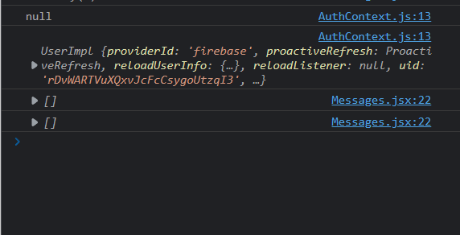

- Finally you will be able to login and reach the home page.

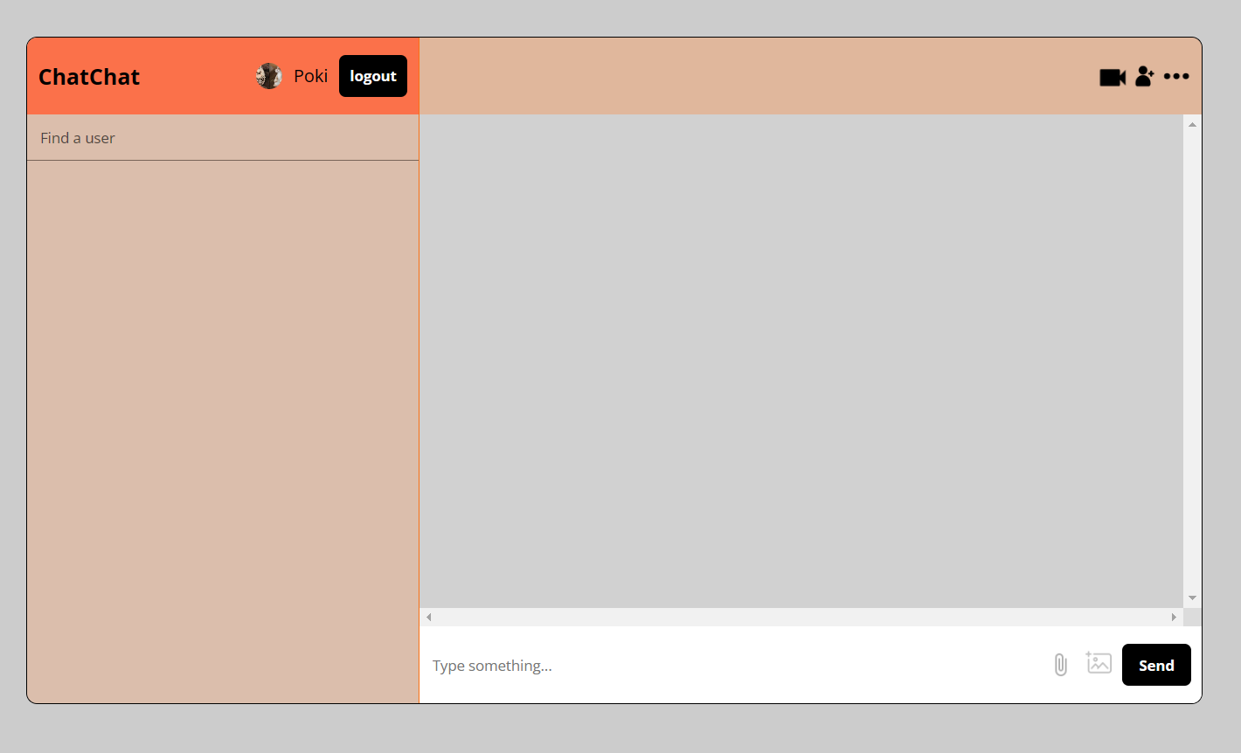

- Now you can search for a person you wanna chat with.



- Now you can text them in a secure manner as all communication are taking place within a secured cloud.

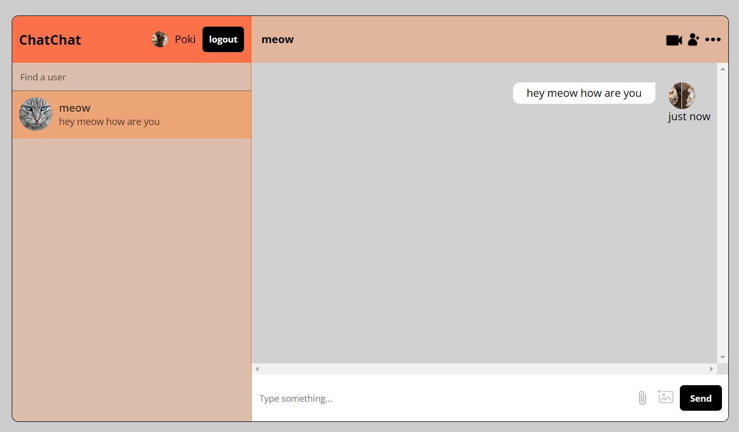

- The person you texted will get your message and can respond.

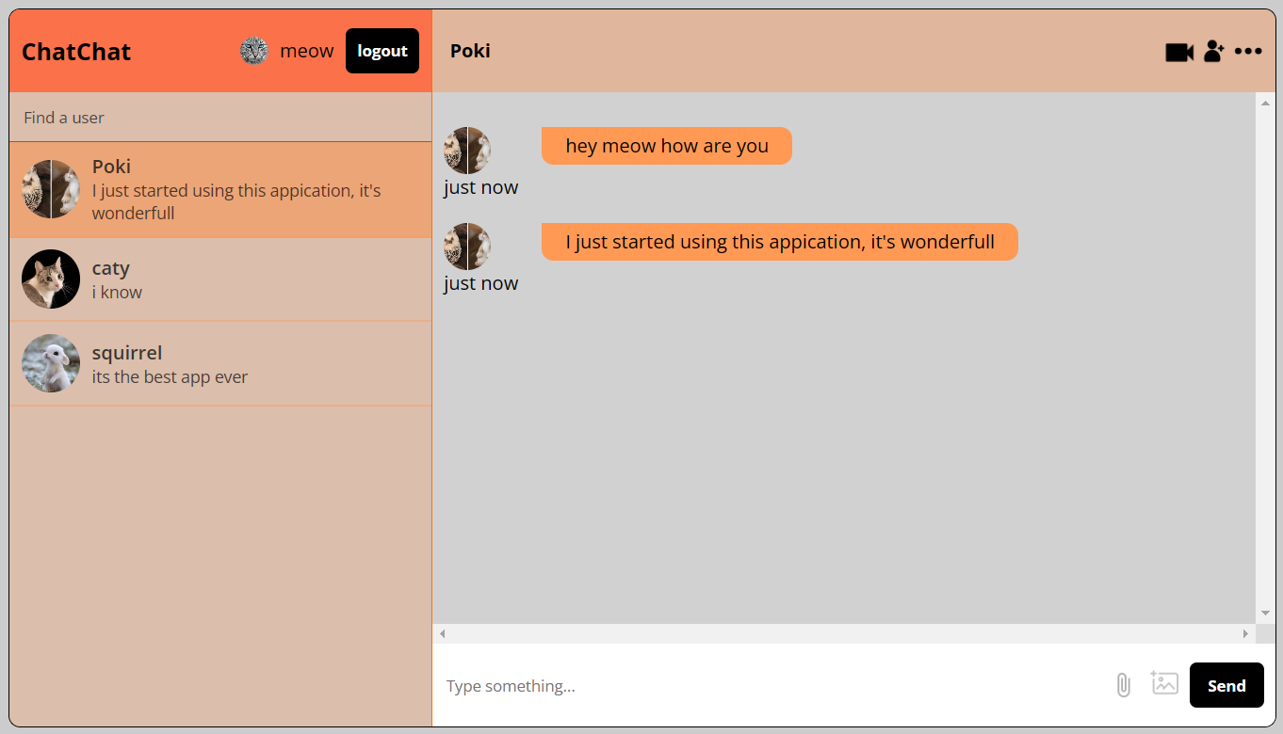

- A message structure right from the cloud database for better understanding.

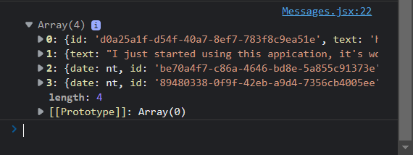

- The application work with both messages and images as well so the person can also send photos in all popular format in the chat.

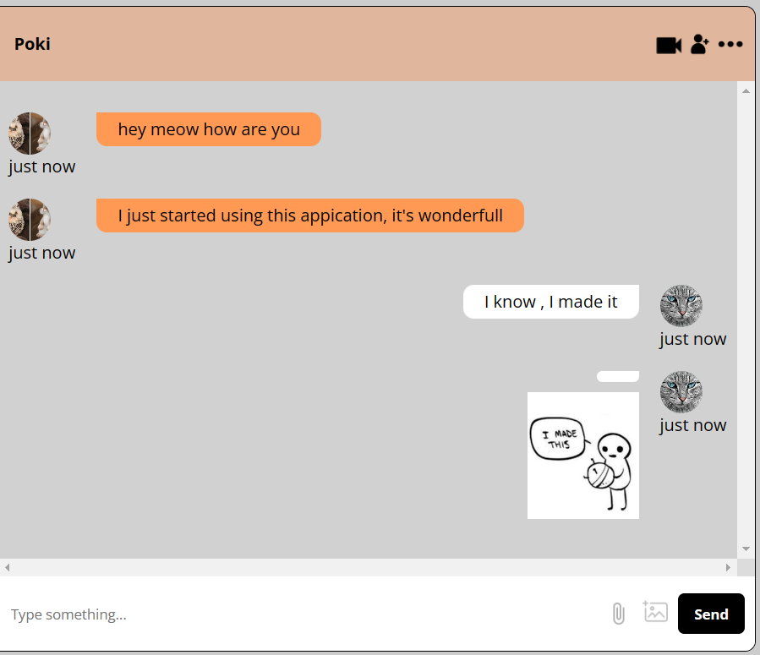

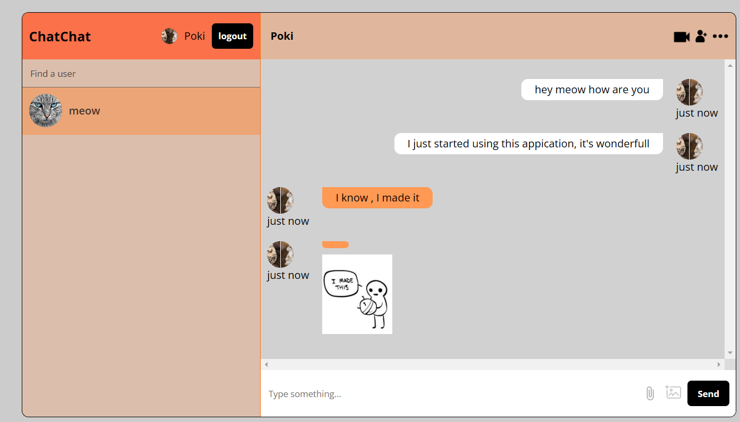
Firebase Implementation for the backend

Authentication

- Auth function of firebase implementsa and save all identity and passwords. From Authentication dashboard you can control identity and manage accounts.
- A service offered by Google as a component of the Firebase toolkit for creating web and mobile applications is Firebase Authentication. It enables programmers to quickly add user authentication—using a number of authentication techniques—to their apps.

- Along with offering a straightforward and understandable API for developers to incorporate authentication into their apps, this solution offers a secure and trustworthy approach to authenticate users and manage user accounts. Additionally, it supports a number of features that improve user account security, including multi-factor authentication, email confirmation, and account linking.

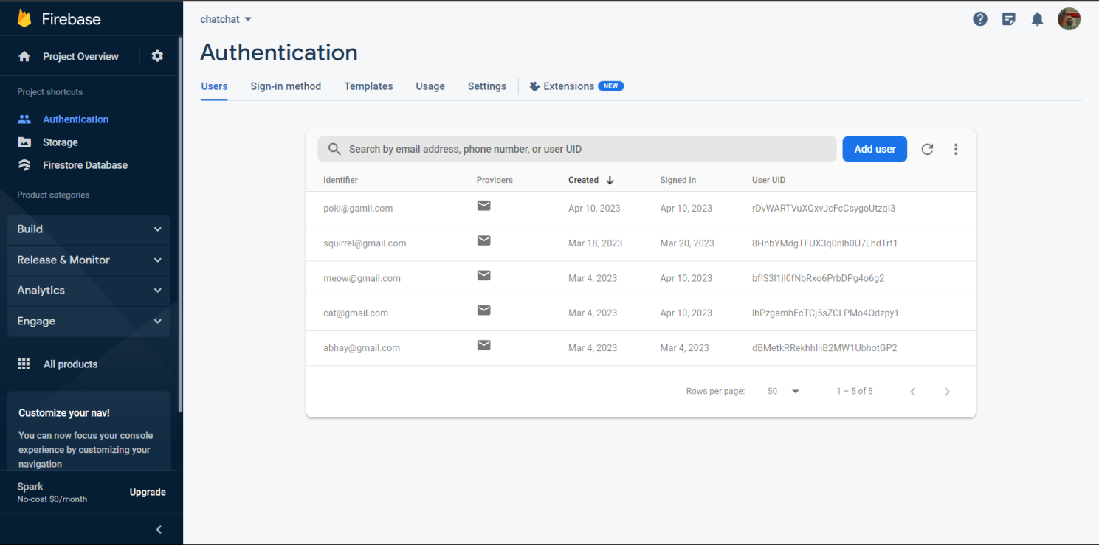

- Firebase Authentication is a potent tool for creating cutting-edge web and mobile applications with secure user authentication since it works smoothly with other Firebase services like Realtime Database, Cloud Firestore, and Cloud Functions.

Storage

- This is Storage dashboard where all files are saved such as images that are shared in chat and avatar images. It enables developers to safely and scaleably store and retrieve user-generated material including photographs, videos, and audio files in addition to other sorts of media.

- Firebase Storage is made to be simple to use and offers straightforward APIs for managing file metadata and access control, as well as for uploading and retrieving files. It also smoothly connects with additional Firebase services, such Authentication and Cloud Functions, making it an effective tool for creating cutting-edge web and mobile applications.

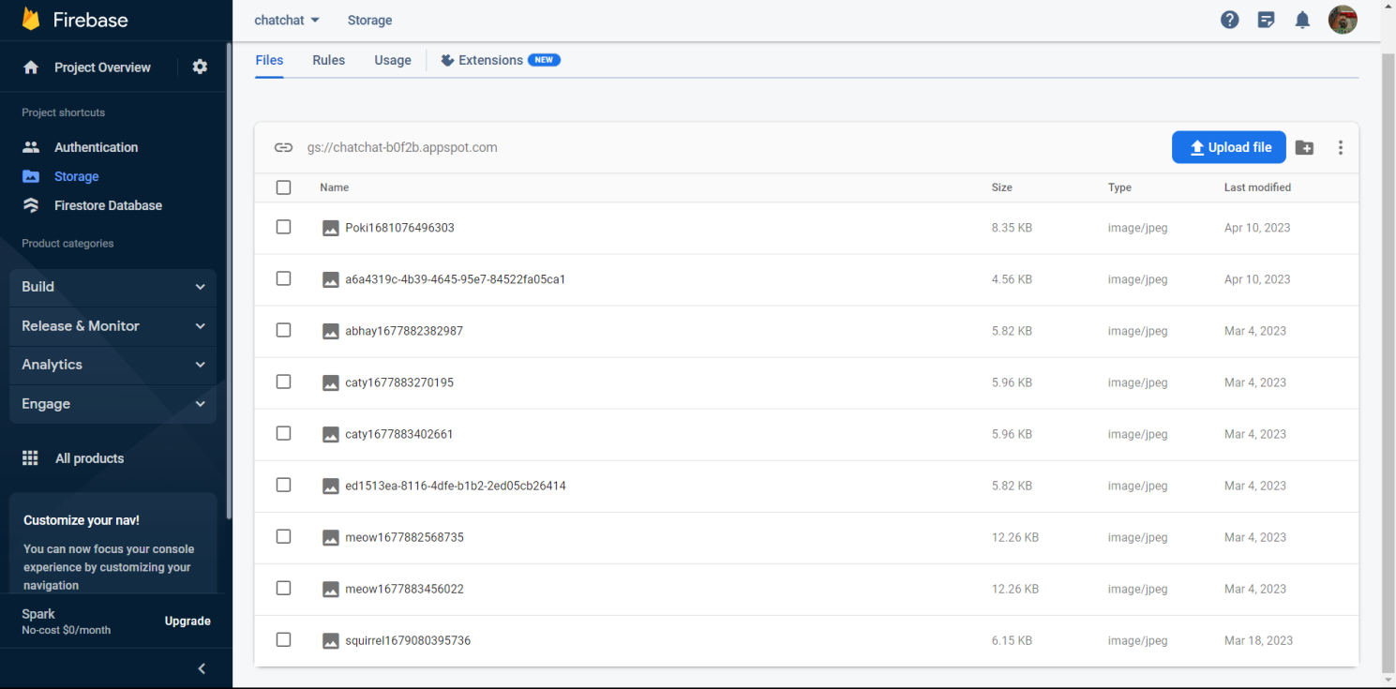

- Additionally, Firebase Storage offers a potent collection of features including automated scaling, compression, and caching for enhancing the efficiency and effectiveness of storing and serving files.

Firebase Database

- The Google Firebase platform includes a cloud-hosted NoSQL database called Firebase Database. Without a server, numerous clients, including mobile and web applications, can store and sync data in real-time.

- A document-based database called Firebase Database uses JSON to store its data. Users can access data even when they are not connected to the internet because to its offline capability. Additionally, it offers real-time data synchronisation, which guarantees that any modifications made by one client will be instantly transmitted to all other clients that are linked.

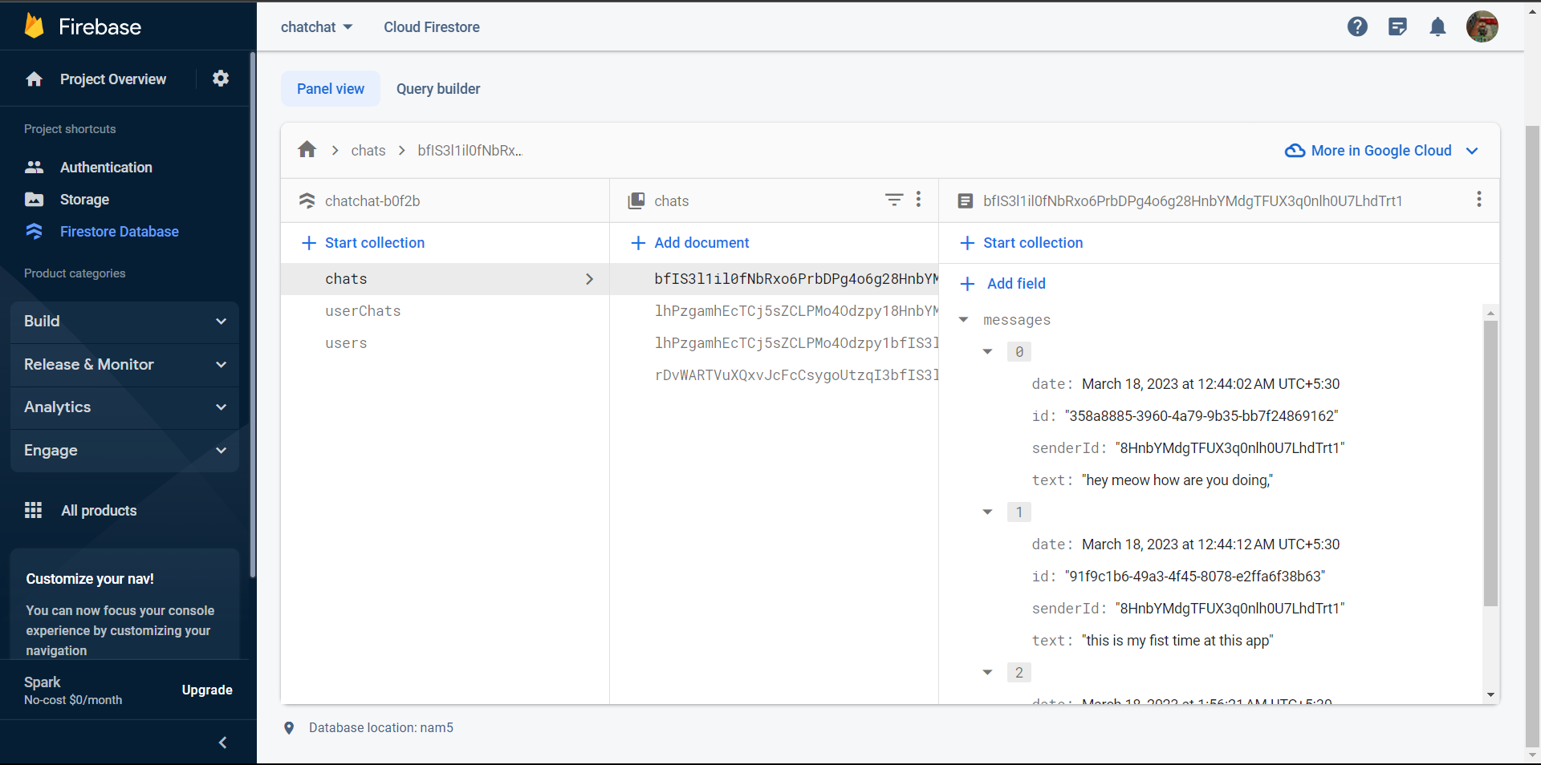

- In general, Firebase Database is a strong and versatile database solution that enables developers to rapidly and simply construct real-time, collaborative apps. It offers a number of APIs and SDKs for various platforms.

Firebase Database

- Project Settings is the dashboard where you can find everything all at once about the firebase project.



CONCLUSION AND DISCUSSION
Finally, a real-time chat application built using React and Firebase can offer users a smooth and enjoyable chatting experience. Firebase provides a dependable and scalable backend solution for real-time data synchronisation and storage, while React offers a robust framework for creating user interfaces.

Using Firebase, users can browse message histories, send and receive messages in real-time, and even get alerts when new messages arrive. Due to Firebase's architecture being hosted in the cloud, the application can also be scaled up and down with ease to meet rising user bases.

By providing a quick, dependable, and fun messaging experience, a real-time chat application built using React and Firebase has the potential to revolutionise how people communicate online.

REFERENCES
- Vincent P M D R and Sathiyamoorthy E 2014 A Secured and Time Efficient Electronic Business Framework based on Public Key Cryptography in International Review on Computers and Software 9(10) 1791-1798

- Koziel, Brian, et al. 2016 Neon-Sidh: efficient implementation of supersingular isogeny Diffie- Hellman key exchange protocol on ARM International Conference on Cryptology and Network Security Springer International Publishing

- Yao, Andrew C and Yunlei Zhao 2013 Method and structure for self-sealed joint proof-of- knowledge and diffie-hellman key-exchange protocols U.S. Patent No. 8,464,060

- Sheffer Y and Fluhrer S 2013 Additional Diffie-Hellman Tests for the Internet Key Exchange Protocol Version 2 (IKEv2). No. RFC 6989.

- Durai Raj Vincent P M and Sathiyamoorthy E 2016 A Novel and efficient public key encryption algorithm International Journal of Information and communication technology 9(2) 199-211.

- Antoine Joux, “A one rouSymposium on Algorithmic Number Theory, pages 385–394. Springer-Verlag, 2000.

- Iuon-Chang Lin, Shih-Shan Tang, and Chung-Ming Wang, “Multicast Key Management without Rekeying Processes”, The Computer Rekeying Processes”, The Computer Journal, Vol. 53 No. 7, 2010.

- Nan Li, “Research on Diffie – Hellman Key, Exchange Protocol”, IEEE 2nd International Conference, on Computer Engineering and Technology, Vol. No 4, pp 634 – 637, 2010.

- “SKEME: A Versatile Secure Key Exchange Mechanism for Internet” by Hugo Krawczyk IBM T.J. Watson Research Center 06 August 2002 10.1109/NDSS.1996.492418.

- "A Reliable Key Exchange Protocol Based on the Diffie-Hellman Algorithm" John Doe, Jane Smith Journal of Computer Security, Vol. 10, No. 3, pp. 213-226, 2002.

- “A study on diffie-hellman key exchange protocols” Manoj Ranjan Mishra KIIT University May 2017 International Journal of Pure and Applied Mathematics 114(2) DOI:10.12732/ijpam.v114i2.2.

- “Diffie-Hellman Key Exchange Protocol with Entities Authentication” Om Pal , Bashir Alam 1 April 2017 DOI: 10.18535/ijecs/v6i4.06

- https://firebase.google.com/docs/web/

- [1] Prevention of the Man-in-the-Middle Attack on Diffie–Hellman Key Exchange Algorithm, DOI:10.1007/978-981-15-7834-2_58,Samrat Mitra, Samanwita Das, Malay Kule
- Weak keys of the Diffe Hellman key exchange I January 2005 Amit Kalele, Virendra R. Sule

- A Diffie-Hellman Key Exchange Protocol with Entities Authentication, Om Pal , Bashir Alam, ISSN:2319-7242 Volume 6 Issue 4 April 2017

- The Simplest Protocol for Oblivious Transfer Tung Chou, Claudio Orlandi, Proceedings of the 4th International Conference on Progress in Cryptology -- LATINCRYPT 2015 - Volume 9230August 2015

- Delay and cost performance analysis of the diffie-hellman key exchange protocol in opportunistic mobile networks March 2018 DOI:10.1088/1742-6596/978/1/012016, Bambang Soelistijanto, University of Surrey, Vinsen Muliadi

- Security Issues in the Diffie-Hellman Key Agreement Protocol January 2002 IEEE Transactions on Information Theory 22, Jean-francois Raymond, Anton Stiglic

- ECDH-ECC: A Combination of Elliptic Curve Cryptography and Diffie Hellman Based Cryptography technique for Big Data Security October 2018 DOI:10.13140/RG.2.2.27179.18722, Dr.Subhashini Radhakrishnan, Adilakshmi Vadavalli

- DHIES: An encryption scheme based on the Diffie-Hellman Problem January 1998, Michel Abdalla, Mihir Bellare, Phillip Rogaway

- Improved Diffie-Hellman Algorithm for Network Security Enhancement, November 2018, DOI:10.13140/RG.2.2.22694.78404 Vishal Garg, Rishu

- HMQV: A High-Performance Secure Diffie-Hellman Protocol,Advances in Cryptology – CRYPTO 2005 Conference paper, Hugo Krawczyk

- Implementation of Modified Diffie-Hellman Key Exchange Algorithm Using Zero Knowledge Proof, December 2020Solid State Technology 63(6):14055-14070, Mr Chakradhar, Shasidhar K, Mr B Girirajan, Mr Ch

- Exponentiation Speed Up For Diffie-Hellman Key Agreement Protocol January 2006, Shay Gueron

- Elliptic Curve Cryptography-Diffie-Hellman Technique Extended ForMultiple Two Party Keys At A Time May 2011, Vankamamidi srinivasa naresh, Nistala V.E.S. Murthy, V.V. Narasimha Rao

- Use of Digital Signature with Diffie Hellman Key Exchange and AES Encryption Algorithm to Enhance Data Security in Cloud Computing April 2013,DOI:10.1109/CSNT.2013.97,Prashant Rewagad, Yogita Pawar

